Project Documentation

Who is the Business in this project? (Tele communication company)
What problem is company facing? (Customer churn)
And why does it matter to them? (Loses of customers means less revenue)
How will my analysis help? (Find patterns and recommend possible actions)

Title: Customer Churn & Transaction Analytics using SQL and Python

Project Objective:
The objective of this project is to analyze customer behavior, churn, and revenue using SQL and Python to help the company understand why customers leave and how customers retention can be improved.

Dataset Overview: Telco Customer Churn (IBM)

Source: IBM Telco Customer Churn Dataset (Real-world dataset)
Rows – 7,043 customers
Columns – 21

Column names
Customer Information  CustomerID  Gender  SeniorCitizen  Partner  Dependents | Services  PhoneService  MultipleLines  InternetService  OnlineSecurity  OnlineBackup  DeviceProtection  TechSupport  StreamingTV  StreamingMovies
Business Information

Contract
PaymentMethod
Churn
MonthlyCharges
TotalCharges
Tenure

Problem and Goal:
The company needs to understand why customers leave and which customer segments contribute the most revenue.

Goal:
Analyze customer behavior, churn, and revenue using SQL and Python to generate actionable business insights that support customer retention strategies.
Project Workflow
Phase 1 — Business Understanding & Data Cleaning
Objective
Understand the business problem and prepare the dataset for analysis.
Tasks
- Define the business problem
- Load the dataset
- Explore the dataset structure
- Check data types
- Check missing values
- Handle blank values
- Remove duplicates
- Fix incorrect data types (especially TotalCharges)
- Verify cleaned data
- Export cleaned dataset
Output
- Business Understanding
- Cleaned Dataset
- Data Cleaning Summary

Phase 2 — SQL Business Analysis
Objective
Use SQL to investigate customer behavior and business performance.

Tasks
- Import cleaned dataset into SQL
- Create database/table
- Write SQL business queries
Analysis
- Total Customers
- Churn Rate
- Total Revenue
- Revenue by Contract
- Revenue by Payment Method
- Revenue by Internet Service
- Customer Distribution
- Average Monthly Charges
- Average Customer Tenure
Output
- SQL Query Results
- Business Insights
Phase 3 — Business KPI Analysis (Python)
Objective
Calculate key business metrics.
KPIs
- Total Customers
- Active Customers
- Churned Customers
- Customer Retention Rate
- Total Revenue
- Average Monthly Charges
- Average Total Charges
- Average Customer Tenure
- Average Revenue per Customer
Output
- Business KPI Summary

Phase 4 — Customer Behavior Analysis
Objective
Identify customer groups that are more likely to churn.
Analysis
- Churn by Contract
- Churn by Payment Method
- Churn by Internet Service
- Churn by Gender
- Churn by Senior Citizen
- Churn by Tenure
Output
- Customer Behavior Insights

Phase 5 — Revenue Analysis
Objective
Analyze revenue across different customer segments.
Analysis
- Revenue by Contract
- Revenue by Payment Method
- Revenue by Internet Service
- Revenue by Customer Segment
- Revenue by Tenure
Output
- Revenue Insights

Phase 6 — Data Visualization
Objective
Present business findings using charts.
Charts
- Churn Distribution
- Revenue by Contract
- Revenue by Payment Method
- Churn by Internet Service
- Customer Tenure Distribution
- Monthly Charges Distribution
- Correlation Heatmap
Output
- Business Charts
- Business Insights

Phase 7 — Business Recommendations
Objective
Provide recommendations based on the analysis.
Examples
- Reduce customer churn.
- Improve long-term customer retention.
- Increase customer lifetime value.
- Improve customer satisfaction.
Output
- Business Recommendations

Phase 8 — AI Business Report (Gemini AI)
Objective
Generate an executive business report.
Include
- Executive Summary
- Key Findings
- Customer Insights
- Revenue Insights
- Business Recommendations
- Conclusion
Output
- AI Business Report

Phase 9 — Export Report
Generate
- TXT Report
- PDF Report
Output
- Final Business Report

Phase 7 - Key Findings

1) High Customer Churn – Churn Rate = 26.58% (1,869 customers) means 1 out of every 4 customers leaves the company. This tells us Customer churn is a significant business problem.
2) Contract Type Strongly Affects Churn – Month-to-Month churns the most, meaning Customers on longer contracts stay longer.
3) Electronic Check Customers have Higher Churn – generate high revenue, but also churn more. Meaning the company is losing valuable customers.
4) Fiber Optic Customers Generate High Revenue – generate the highest revenue also show higher churn. Meaning valuable customer segment is at risk.
5) Long-Term Customers Generate More Revenue – Scatter plot showed- longer tenure – higher total charges. Meaning retaining customers increases lifetime revenue.
6) New Customers Leave More Often – Tenure analysis showed – 0-12 Months customers – highest churn, most customers leave early.
7) Senior Citizen Segment – analysis shows differences between Senior and Non-Senior customers. However, additional churn-rate analysis is required before concluding that Senior Citizens are more likely to churn.
8) Customer Retention Drives Revenue – Heatmap, Scatter plot, Revenue Analysis all point to the same conclusion customer staying longer – generate much higher lifetime revenue. Biggest finding of project.

Questions-
Why are customers leaving?
Which customers are leaving?
Which customers generate the most revenue?
Which customer groups are valuable?
Which factors affect churn?
Which business areas need improvement?

Chart 1
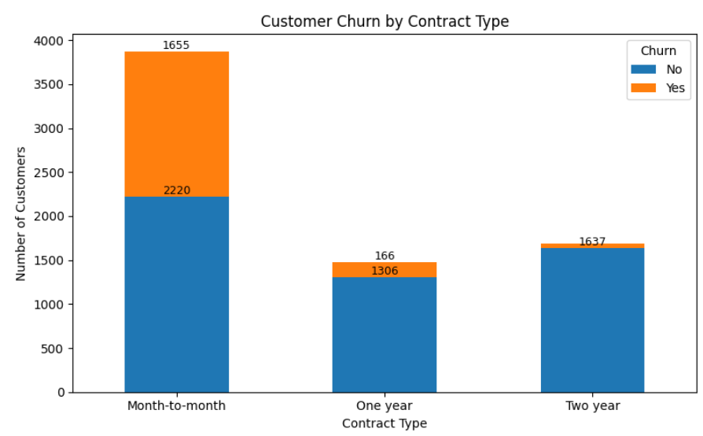

Business Insight:
Customers with Month-to-month contracts experience the highest churn, while customers with One-year and Two-year contracts show much higher retention. Longer-term contracts improve customer loyalty.
Chart 2
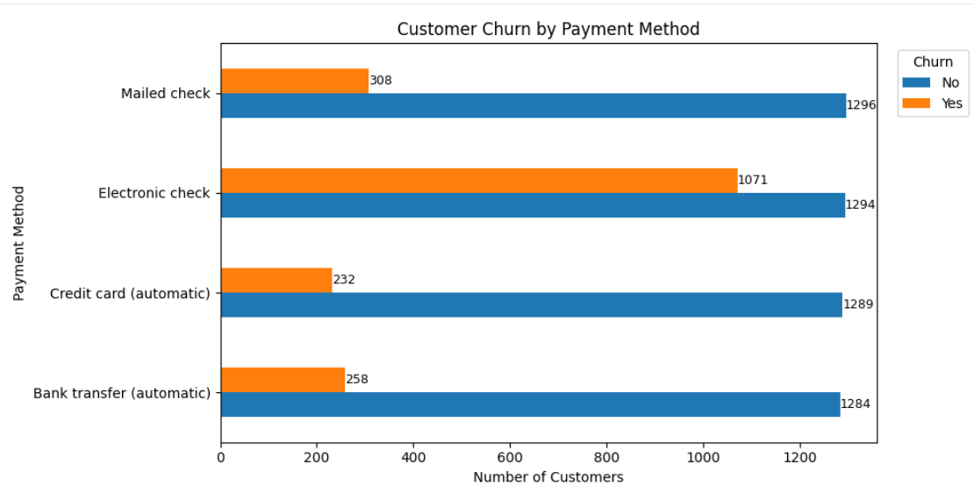

Business Insight:
Customers using Electronic Check have the highest churn compared to other payment methods. Customers using automatic payment methods tend to remain with the company longer.

Chart 3
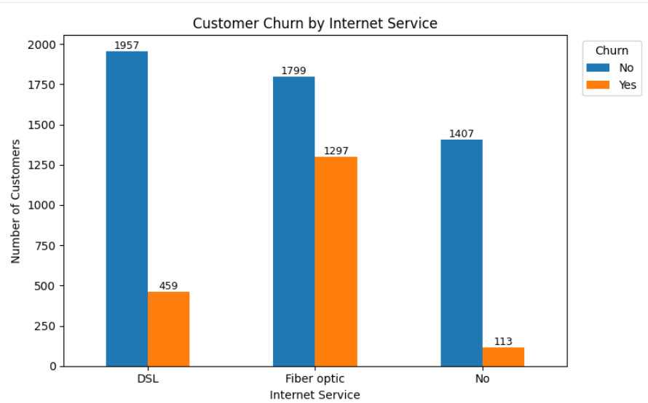

Business Insight:
Customers using Fiber Optic internet service have the highest churn, while customers with DSL or no internet service show lower churn levels. Service quality or pricing for Fiber Optic customers may require improvement.

Chart 4
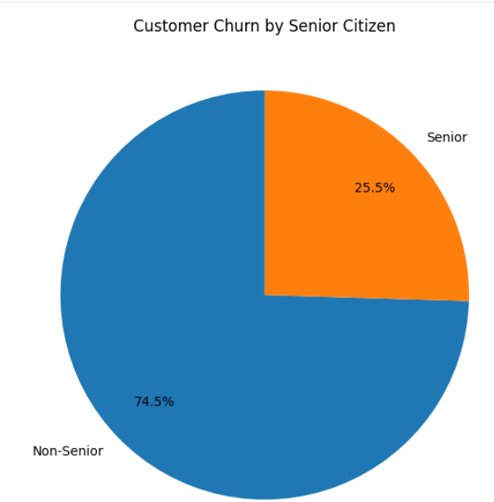
Business Insight:
Senior citizens account for a higher proportion of churn relative to their customer base, suggesting they may require additional support, personalized services, or targeted retention programs.

Chart 5
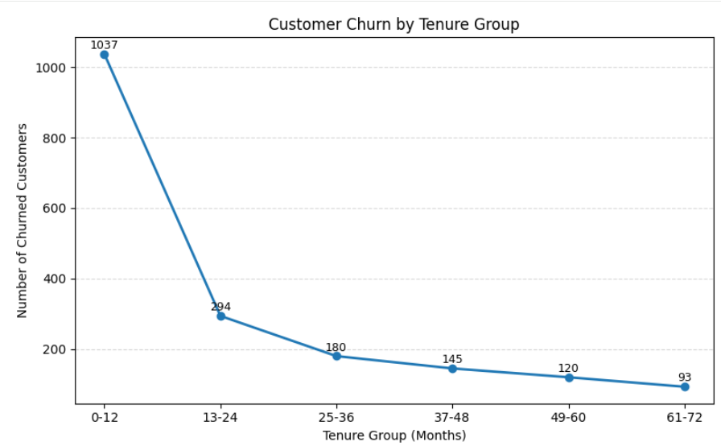
Business Insight:
Customers with shorter tenure (0–12 months) experience the highest churn, while customers with longer tenure are generally more loyal and less likely to leave.
Chart 6
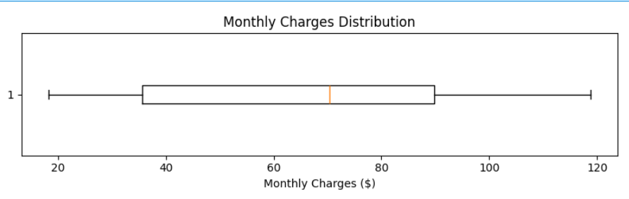
Business Insight:
Monthly Charges range from approximately 18 to 119, with a median monthly charge of around 70. The wide distribution indicates that the company serves customers across multiple pricing tiers, from basic to premium service plans.

Chart 7
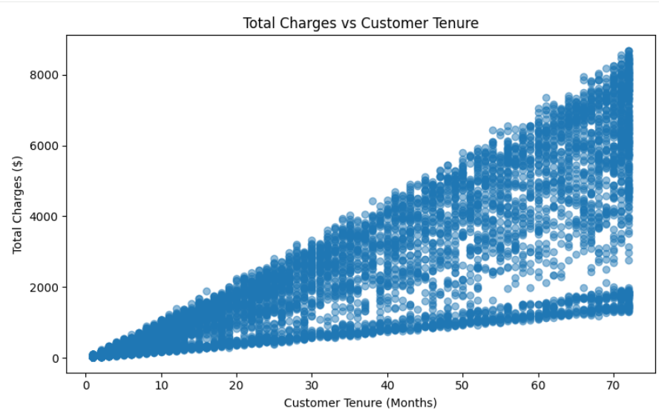

Business Insight:
Customers with longer tenure generally generate higher total charges, with some contributing over $8,000 in lifetime revenue. This highlights the importance of retaining customers over the long term.

Chart 8
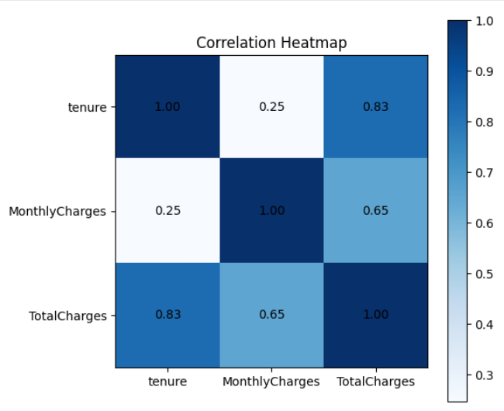
Business Insight:
Customer tenure has the strongest relationship with Total Charges, indicating that long-term customers contribute the highest lifetime revenue.

